**MMS2plot user guide**

Liya Ming & Lei Li

Written on September 16, 2019

**Brief introduction**

MMS2plot, an R package for visualizing and comparing peptide-spectrum matches (PSMs) assigned to non-modified peptides and the corresponding modified peptides, compatible with proteomics data generated from LC-MS/MS analysis. MMS2plot uses an automated analysis pipelines and offers both mirrored-spectra view and aligned-spectra view; and in either case, the displayed spectra share the same x-axis. The spectra view may be employed to compare mass shifts, intensities and matches of peaks between the modified and non-modified peptides. Additionally, MMS2plot features a batch mode and generates the output images in vector graphics file format that facilitate evaluation and publication of the PSM assignment.

1. **Installation of MMS2plot**

MMS2plot can be run on multi-OS systems (such as Windows and Linux) and are freely available through <https://github.com/lileir/MMS2plot>. It can be directly installed from GitHub using the library “devtools” under the R environment. (**Figure 1**):

>if( !requireNamespace("devtools")) install.packages("devtools")

>library(devtools)

>devtools::install_github("lileir/mms2plot")

>library(mms2plot)

**Figure 1**. Installation and loading of MMS2plot

Note:

1. The version of the “devtools” package should be >2.2. Otherwise, the “mms2plot” package cannot be installed successfully.
2. The “mms2plot” package depends on R (>= 3.5) and requires the following packages (xml2, data.table, DescTools, MSnbase, scales, Biobase, gsubfn, graphics, grDevices).
3. Please note that if the installation fails and
4. The failure of the “mms2plot” installation is mainly due to the following reasons:

* The required packages previously installed is out of date, especially for the “devtools” package. Please update the packages.
* The error message is shown as : “Error in utils::download.file(url, path, method = download_method(), quiet = quiet, : cannot open URL 'https://api.github.com/repos/lileir/mms2plot/tarball/master'”. This failure is due to the slow internet speed. Please re-run the command.
* Failure of installation of the required packages, especially for iOS or linux. It is better to install binary version of the packages. If the error “['tar: Failed to set default locale' error?](https://stackoverflow.com/questions/3907719/how-to-fix-tar-failed-to-set-default-locale-error)” appears, please refer to the link [https://stackoverflow.com/questions/3907719/how-to-fix-tar-failed-to-set-default-locale-error/45469967#45469967](https://stackoverflow.com/questions/3907719/how-to-fix-tar-failed-to-set-default-locale-error/45469967%2345469967). If you install packages from their source versions, please make sure that the compilation environment works fine.

1. After installation and loading of this package, the command “help(mms2plot)” can be executed to view the help information.
2. **Examples in the help(mms2plot) page**

After the installation of the mms2plot package, the typical thing a user would like to do is to follow the example in the help page. Figure 2 shows the commands and the output of the label-free example.

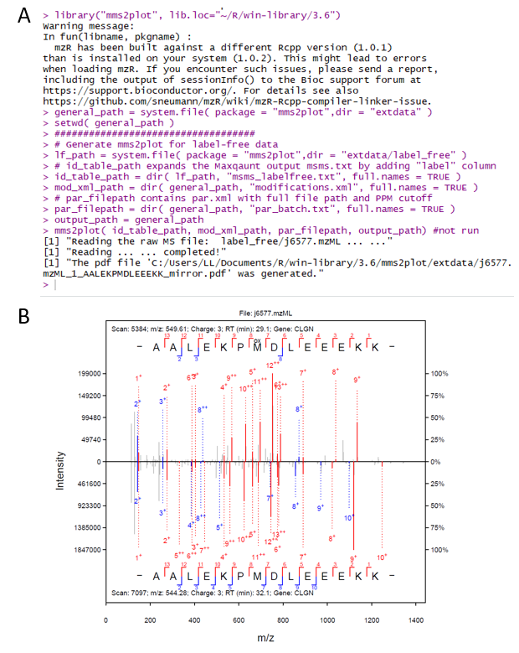

**Figure 2. A.** The commands of the label-free example in the mms2plot help page. **B**. The output of this example.

1. **Generation of MMS2plot required files**

The MMS2plot required files include both input files and supported files. **Supplementary Data 1** contains the example files. It can be downloaded and unzipped to a given folder (e.g. “D:\test”). This folder includes two subfolders:

1. “input”, which covers three files: modifications.xml, identification.txt and parameter_batch.txt;
2. “support”, including two parameter files (parameter1.xml & parameter2.xml) and two raw MS files (rawMS1.mzML & rawMS2.mzML).

These required files are described as below:

**2.1.** The modifications.xml file. This file is directly derived from the Maxquant software. If the modification of interest is not included in the xml file, this modification can be added to the xml file through Maxquant. In the some versions of Maxquant, the modification information is stored in two xml files: modifications.xml and modifications.local.xml. Please combine them as a single xml file.

**2.2.** The identification.txt file. This text file contains eight necessary columns (as listed below) whereas any other columns will be ignored (**Figure 3**).

1. “Raw file”: the full file path of the MS raw file with the mzML format, for example, “D:\test\support\rawMS1.mzML” for Windows OS and “/test/support/rawMS1.mzML” for Linux OS.
2. “Scan number”: the RAW-file derived scan number of the MS/MS.
3. “Sequence”: the identified Amino acid sequence of the peptide.
4. “Modifications”: PTM types contained within the sequence, for instance, “Oxidation(M)”. When no modifications exist, “Unmodified” should be filled.
5. “Modified sequence”, sequence representation of the peptide including location(s) of modified amino acids.
6. “Gene Names”: names of genes that the identified peptide is associated with.
7. “Charge”: the charge state of the precursor ion.
8. “label”: a number assigned to the peptide-spectra matches (PSMs) that share the x-axis (i.e. m/z) of the output image.

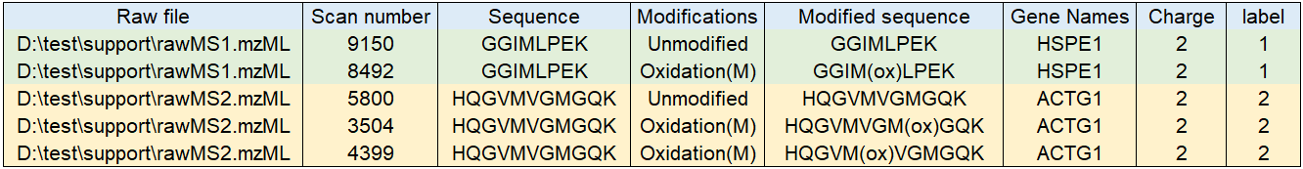

**Figure 3**. An example of the identification.txt file that contains the information of five PSMs. The first two are used to generate the mirrored spectra and the other three are employed to produce the aligned spectra.

**2.3.** The parameter batch text file (named as parameter_batch.txt in supplementary data 1). This text file contains two columns: the full file path of the parameter XML files and the fragment mass tolerance set in the Parts per Million (ppm) for each XML file (**Figure 4**). The format of the parameter file is described in **2.4**.

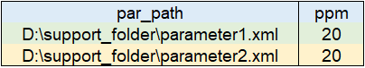

**Figure 4**. An example of the parameter batch file that contains two parameter files.

**2.4.** The parameter XML file. This file includes the raw MS filenames and the modifications that are defined for MS spectral analysis. This parameter file has the same XML format as the mqpar.xml file in Maxquant and thus it can be directly generated using Maxquant.

**2.5.** The raw MS files in standard mzML format. Figure 1 shows two mzML files. The conversion of MS data files to the mzML format can be done using the MSConvert application tool in ProteoWizard. In addition to the **msConvertGUI** program, the command line tool **msconvert** is more efficient for batch conversion (**Figure 5**).

**Figure 5**. The msconvert program is operated to convert two MS2s (scan number 9150 and 8492) from rawMS1.raw into the mzML format and saved to the designated path.

"C:\ProteoWizard\msconvert.exe" D:\Raw\rawMS1.raw --filter "scanNumber [9150,9150] [8492,8492]" –o D:\test\support\

1. **Argument settings of MMS2plot**

The function mms2plot requires four necessary input arguments while and the other arguments have default values. The four necessary arguments are as follows (**Figure 6**):

1. “id_table_path”, representing the path of the identification file ;
2. “mod_xml_path”, representing the path of the modification xml file;
3. “par_filepath”, representing the path of the parameter batch file;
4. “output_path”, representing the path of the folder used to save the output spectra.

>id_table_path = "D:/test/input/identification.txt"

>mod_xml_path = "D: /test/input/modifications.xml"

>par_filepath = "D:/test/input/parameter_batch.txt"

>output_path = "D:/test"

>mms2plot(id_table_path, mod_xml_path, par_filepath, output_path)

**Figure 6**. An example of the four arguments required for MMS2plot. Note: In windows OS, a single forward slash (or double backslashes) is used to separate the folders.

1. **Outputs of MMS2plot**

Two output pdf files of MMS2plot are generated and saved to the specified folder (e.g. “D:\test”). The pdf file name is designated to contain four types of information (the raw MS file name, the label number, the identified peptide sequence and the type of visualization (mirror or align)), which are separated by the underline characters (**Figure 7&8**).

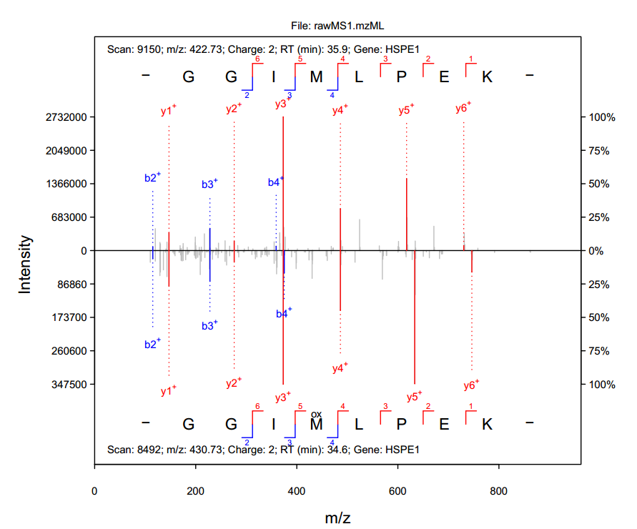

**Figure 7**. The image of the pdf file rawMS1.mzML_1_GGIMLPEK_mirror.pdf.

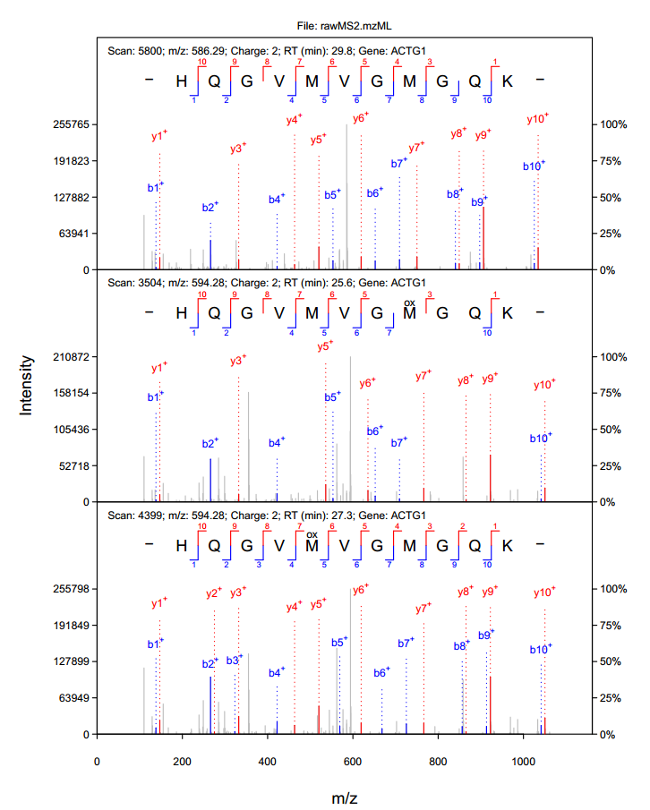

**Figure 8**. The image of the file rawMS2.mzML_2_HQGVMVGMGQK_align.pdf.